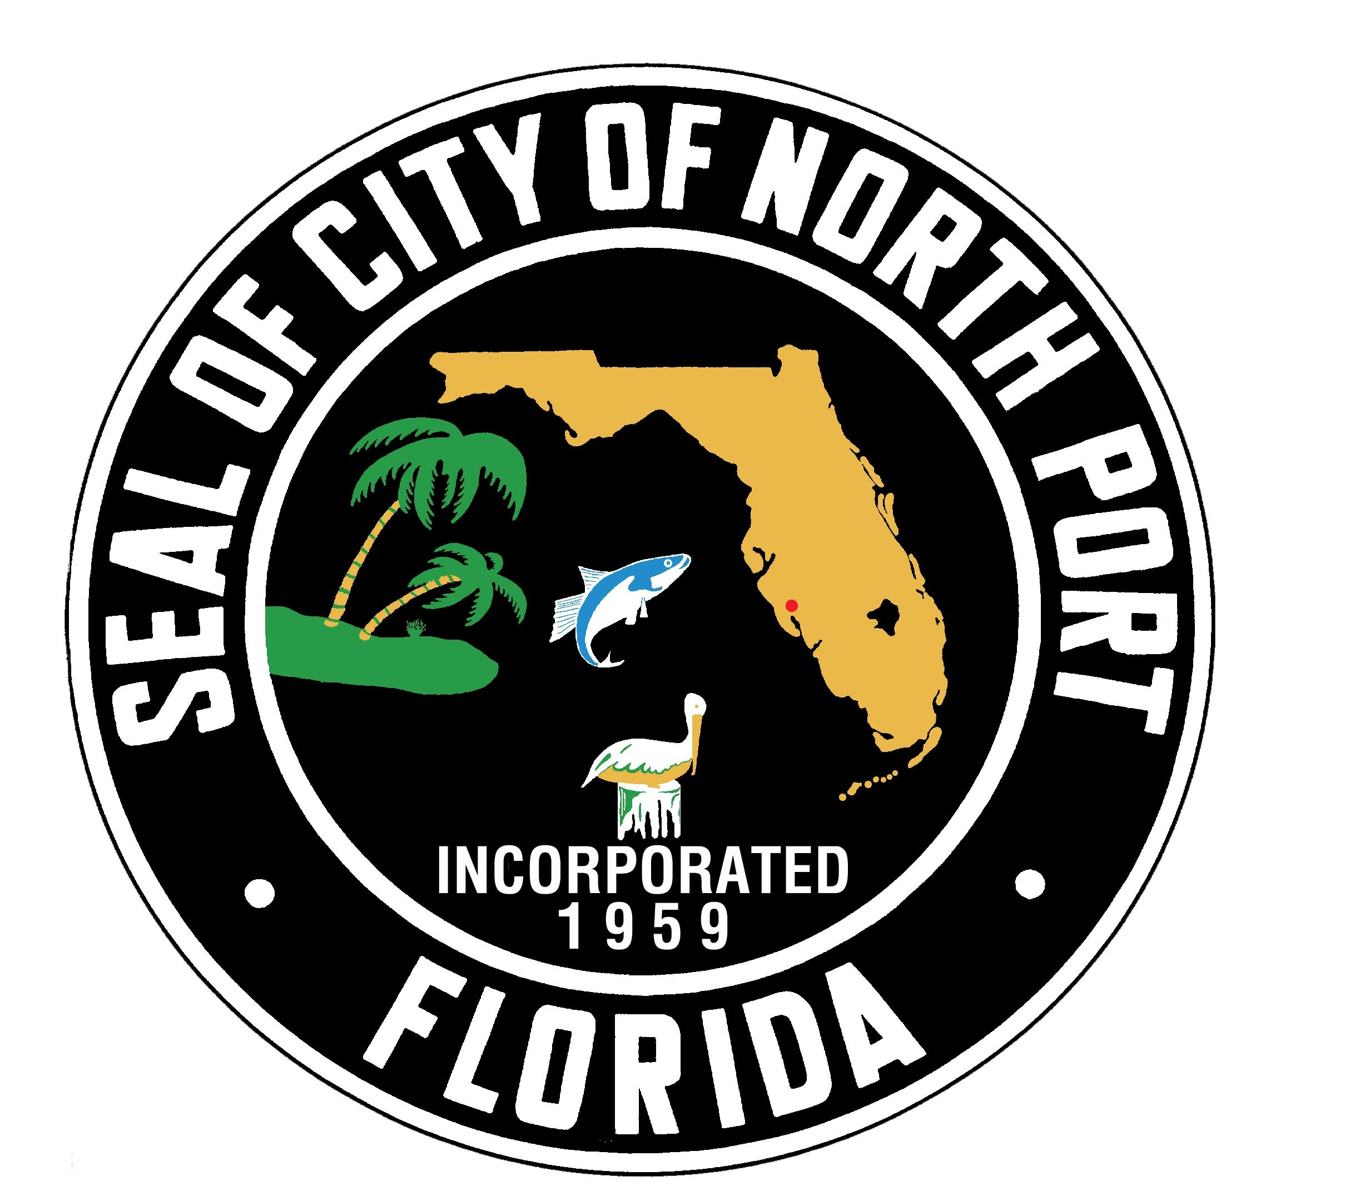
City of North Port
Solid Waste
Special Collection Service Request₁₂
City Code Section 62-50 (f)* and (g)

I_______________________________, request that I be provided with special solid waste collection services because I have a disability. I certify there is no other person in my household that is able to carry garbage, recycling and/or yard waste containers to the curb at the address located below.

Address:________________________________________ Home Phone:________________________

Last Name:_________________________________ First Name:_______________________________

Cell Phone:__________________________ Email:__________________________________________

Provide location of garbage, recycling and/or yard waste containers:___________________________

__________________________________________________________________________________

This Indemnification, Hold Harmless Agreement and Permission Notice is between the above listed resident and the City of North Port Solid Waste Division (City). In consideration of the provision of special solid waste collection services by the City, indemnitor agrees to indemnify and hold harmless the City from and against all liability and loss, including attorney’s fees and court costs, that the City may sustain as a result of claims, demands, costs or judgments arising from the special collection of indemnitor’s solid waste. This agreement is effective from the date of signing, and will remain in effect as long as indemnitor receives special solid waste collection services from the City.

The signature below also gives the City of North Port Solid Waste Division employees authorization to enter the indemnitor’s property for the purpose of solid waste collection.

Resident Signature:____________________________________________ Date:________________

*Persons with physical disabilities who seek an exemption from the requirements of subsection (a) shall present to the City of North Port Public Works Department a certification by a physician licensed to practice medicine within the State of Florida that the applicant has one of the physical disabilities identified in F.S. § 320.0848(1)(a) or such other physical disability that would necessitate the provision of special solid waste collection service.
FOR OFFICIAL USE ONLY: Date physician certification received:_________________Collection day:______________

City of North Port Solid Waste Division, 1100 N Chamberlain Blvd, North Port, FL 34286
Phone: 941-240-8050 Fax: 941-240-8063 www.cityofnorthport.com

Physician’s Certification

Print name of physician licensed to practice medicine within the State of Florida:

___________________________________________________________________________________

Medical License # ____________________________________________________________________

Address____________________________________________________________________________

Telephone #________________________________________________________________________

Check appropriate box:

- Temporary disability until _____________________________(give specific date of expiration)

- Permanent disability

I certify that the applicant has one of the physical disabilities identified in Florida Statute F.S. § 320.0848(1)(a) or such other physical disability that would prevent him/her from carrying garbage, recycling and/or yard waste containers to the curb. I have indicated above whether this is a temporary or permanent disability.

_______________________________________________________ Date_______________________
Signed name

City of North Port Solid Waste Division, 1100 N Chamberlain Blvd, North Port, FL 34286
Phone: 941-240-8050 Fax: 941-240-8063 www.cityofnorthport.com

